Chapter 6 Magnetic field and EMF
Chapter Test Total marks 47

Name: __________________________ Class: ______ Date: ______
A data sheet with appropriate physics constants will be provided for this test.
Question 1
A student sets up the equipment shown below to conduct an experiment to measure the change in current when a magnet is moved in and out of the wire coil. The student sets up the magnet to move in and out of the coil at a constant rate and measures the current on the ammeter.

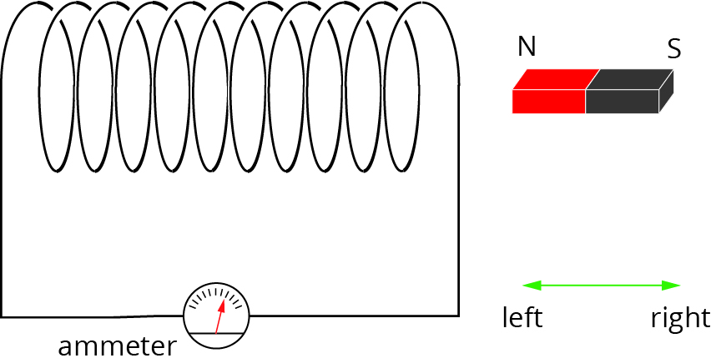

- On the axes below, sketch a graph of current versus time to show how the current will vary as it is moved in and out for one cycle (i.e. from 0 to t seconds the magnet moves all the way in and from t to 2t seconds it moves completely out of the field). Label the axes and significant points on the axes. (4 marks)
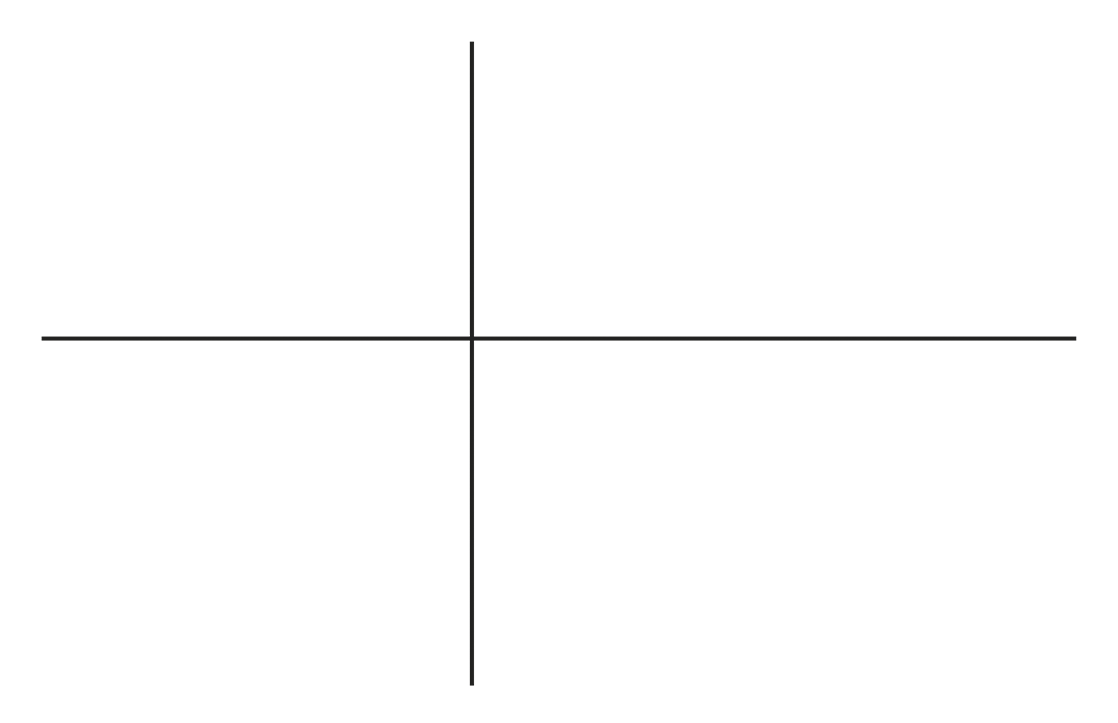

- On the coil, draw arrows to show the direction of the induced current when the magnet is moving to the left. (1 mark)

- If the magnet was turned around the other way for a second trial, how would the induced current compare to the original trial? Assume that the rate at which the magnet moves in and out of the field is the same in both trials. (2 marks)

Question 2
In an experiment to determine the strength of the magnetic field in his location, a scientist attaches a rigid 5.00 m aluminium pole to the top of a car so that the pole is horizontal and oriented in a north-south direction. The car is travelling at a constant velocity of 60 km h⁻¹ towards the east. The ends of the pole are attached to wires that lead to a voltmeter, which gives a reading of 6.42 mV.

- Calculate the strength of the vertical component of the earth’s magnetic field at this location. (4 marks)

- Which end of the aluminium pole has a negative potential? (1 mark)

Question 3
A model village has 15 electrical components, each rated as 6 V and 0.5 A, connected in series. The model’s circuit is connected to the secondary coil of an iron core transformer that has a 1000-turn primary coil. The primary coil is connected to the
240 V 50 Hz mains supply.

- What total voltage will the circuit need to have supplied to operate the
15 components? (1 mark)

- What is the number of turns in the secondary coil of the transformer? (2 marks)

- Determine the power being supplied by the secondary coil. (2 marks)

- If the transformer has an efficiency of 85%, find the power supplied by the primary coil of the transformer. (2 marks)

- What may cause the loss of power from the primary coil to the secondary coil and how may this problem be reduced? (2 marks)

Question 4
A drone helicopter with metal rotor blades of length 15 cm from axis to tip is flying in Perth, where the vertical component of the Earth’s magnetic field is approximately
5 × 10⁻⁵ T upwards.
- What is the magnetic flux due to the Earth’s magnetic field that passes through the area swept out by the rotor blades? (3 marks)

- If the rotor spins at 10 revolutions per second, what is the magnitude of the EMF induced between the axis and the tip of the rotor blade due to its rotation in the Earth’s magnetic field? (3 marks)

Question 5
The efficiency of all motors is reduced by a problem known as ‘back EMF’. This is the phenomenon where an EMF develops in the armature coils of the motor. Briefly explain why a motor will generate a current and why it reduces the efficiency of the motor.
(3 marks)

Question 6
An engineer was testing a new generator for a wind turbine. The turbine was placed in a wind tunnel and connected to the generator, and the voltage produced over time was measured.
The generator consisted of a coil of 5000 turns and radius 50 cm. The graph below shows the results of these measurements.
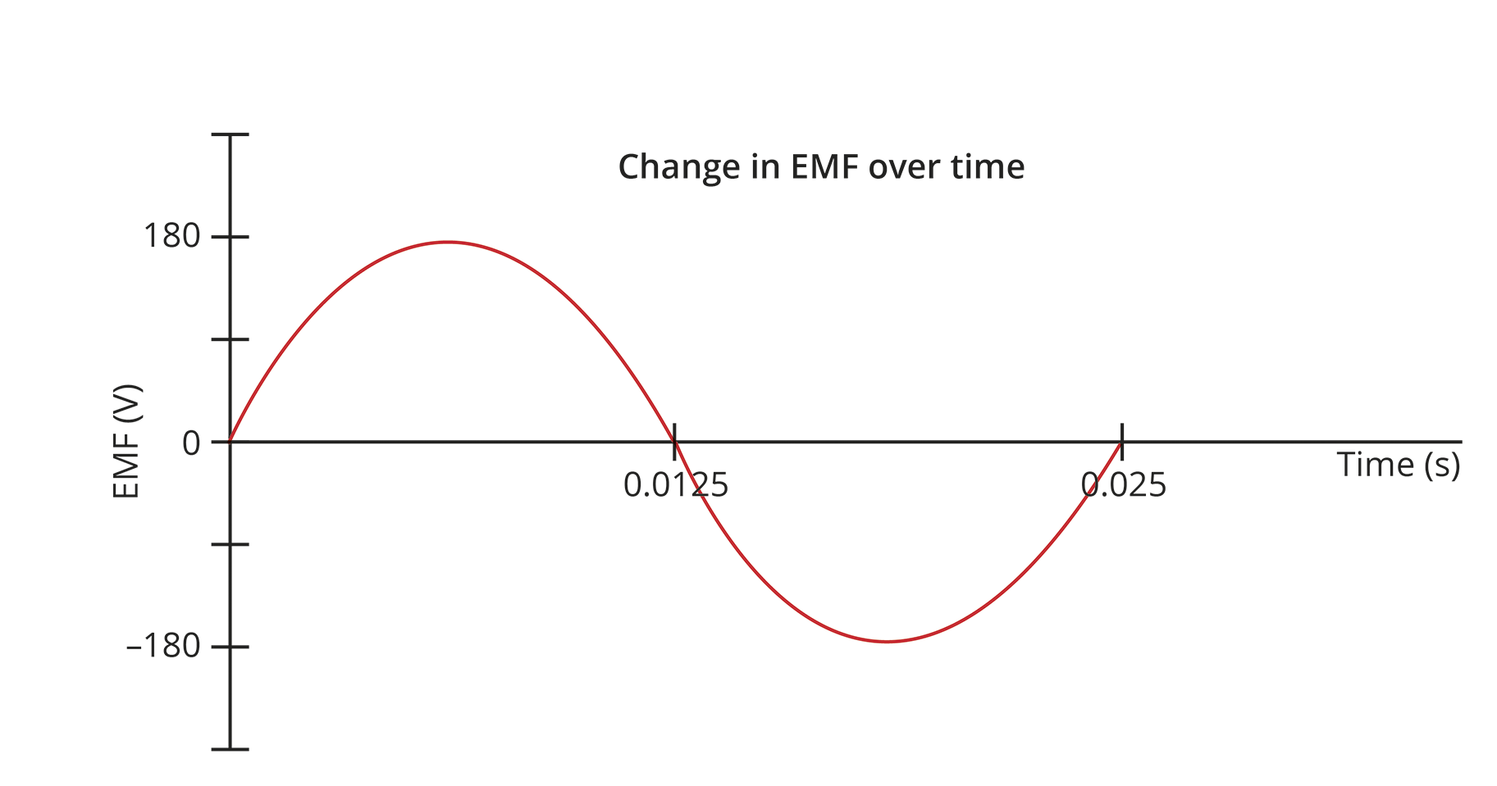

- What is the frequency with which the generator rotates? (1 mark)

- What is the strength of the magnetic field used in this generator? (5 marks)

- What is the root mean square average EMF produced by the turbine? (2 marks)

- The engineer adjusts the wind speed in the wind tunnel and alters the gearing on the turbine so that the generator rotates with twice the frequency as originally. Sketch a graph of how EMF varies with time under these new conditions. (2 marks)

- Identify three changes the engineer can make to the design of the generator to increase the maximum EMF produced by it. (3 marks)

Question 7
The Kwinana Power Station in Naval Base, Western Australia, has a generating capacity of 420 MW. The power station is located long distances from the homes to which it supplies power, and it is not practical to send the current along wires at 240 V (the voltage directly used in the home) as this would lead to large power losses in the wires carrying the current. Instead the power station has 66 000 V, 132 000 V and 330 000 V transmission lines to the South West Interconnected System.

- Explain why there would be large losses if the power were to be supplied at 240 V. Include in your answer any mathematical relationships that are relevant. (2 marks)

- Suggest a reason why there are three transmission lines to the South West Interconnected System of 66 000 V, 132 000 V and 330 000 V. (2 marks)

